EXPERIMENT - 8
Privilege Escalation Using TryHackMe
Step 1: Login to Platform
Open TryHackMe and log in
Step 2: Open Room
Search for Linux Privilege Escalation and join the room.
Step 3: Start AttackBox
Launch the AttackBox and open the terminal.
Step 4: Perform Enumeration
Check user details, system information, and permissions to identify possible vulnerabilities.
Step 5: Identify Vulnerabilities
Look for misconfigurations such as sudo permissions, SUID files, weak file access, or cron jobs.
Step 6: Escalate Privileges
Exploit the identified vulnerability to gain higher privileges (root access).
Step 7: Verify and Complete Tasks
Confirm root access and capture required flags to complete the exercise.

Output:

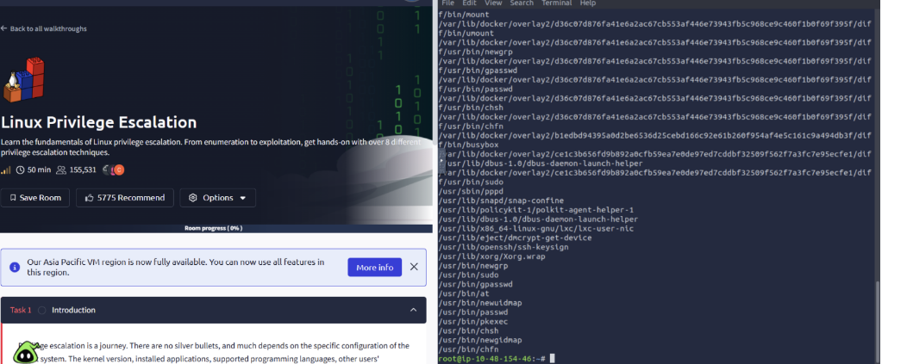
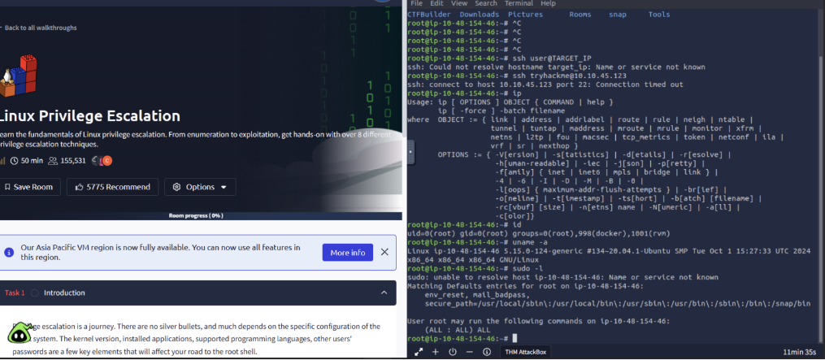
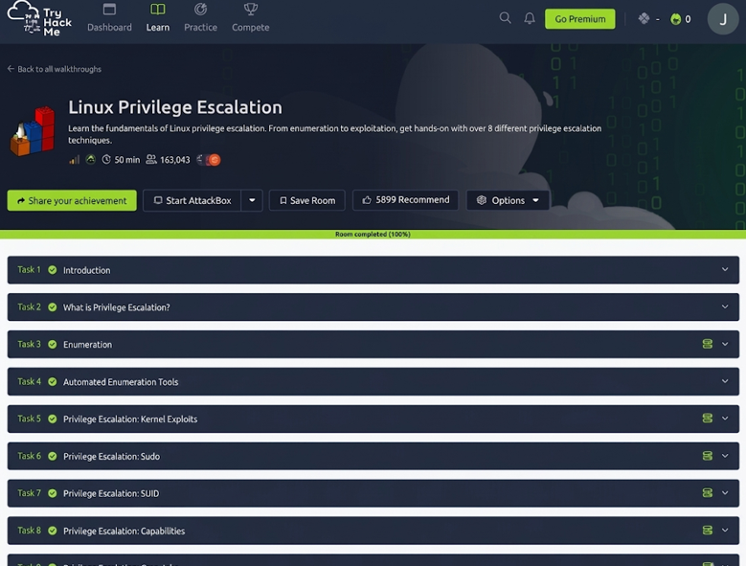

Result:
Privilege escalation was successfully performed, demonstrating how system misconfigurations can lead to unauthorized access and highlighting the importance of secure system practices.

